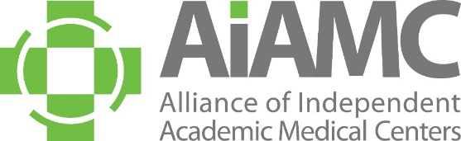

OFFLINE REGISTRATION FORM

National Initiative X

Meeting One

Name:

Title:

Organization: ­­­­­­­­­­­­____________

E-Mail: ____________

**Registration Fees: National Initiative X Meeting One**

□ $330 Team Member Registration

□ Optional Orientation for Those New to the AIAMC National Initiative and/or Those Who Would Like a Refresher: Tips for Success  **FREE/No Cost to Attend but pre-registration is required**

□ Reception (Thursday October 16th 5:00 - 6:00 pm on-site **FREE/No Cost to Attend but pre-registration is required**

□ Dinner (Thursday October 16th 6:00 - 7:00 pm on-site **FREE/No Cost to Attend but pre-registration is required**

**Payment:** □ American Express □ Visa □ MasterCard

Account #:

Amount: Exp. Date: CCID Code:

Billing Zip Code:

Send completed form to AIAMC Administrative Coordinator Mindi Apicella via email [mindi@aiamc.org](mailto:mindi@aiamc.org).

If you prefer to call-in your credit card information, Mindi’s direct line is 407.709.5520.

A receipt will be emailed to the address you provided above.